The Ross Traders 2020

Posted 10.02.2020
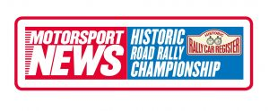Supported by 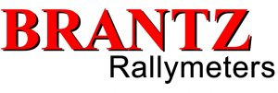
1st Feb 2020
Ross + District Motor Sports Club
Starters: 40
The 2020 season kicked off in style for Howard Warren and Iain Tullie in their Porsche 911 winning the Ross Traders by over 4 minutes from of Paul Crosby and Ali Procter’s Porsche 911 who were 2 minutes ahead of Paul Dyas and Michael Gilbey in the Volvo Amazon. This trio had swapped the lead throughout the event with Paul Dyas and Michael Gilbey only losing it on the penultimate regularity, amazingly this was Michael Gilbey’s first regularity rally.
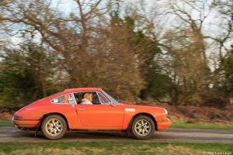
Howard Warren and Iain Tullie Winners of the 2020 Ross Traders. Photo By Tony Large
The format of the event appeared simple, all the tests at the Caerwent Military base with Regularities in the Wye Valley, split 6 tests and 2 regs in the daylight and 3 tests and 3 regs in the dark, however the Traders organising Team had ways of spicing things up.
The first test gave crews a good idea on how they had done this, being 3 miles with 50 junctions, only 17 cars beat bogey! Crosby/Procter took the win from Warren/Tullie with Clive Martin/Anji Martin (Ford Escort) quickest Expert and Roger Fildes/Lynsey Procter (MGB) being the only Novices to beat bogey. After the second test Howard Warren quipped “these tests are a bit long” Iain replied “the next ones 5 miles!” they knuckled down and won the 5 miler by 6 seconds from Dyas/Gilbey. Crosby and Matt Nichol-Jones (Lancia Fulvia) both suffered punctures with bullet casings through the tyre fortunately neither crew lost time.
The first regularity which was pre-plot, proved easy enough Warren/Tullie dropping 15, Dyas/Gilbey 16 with Keith Jenkins/Tony Brooks (SAAB) on 19 best Experts and Dominic Hodge/Peter Raine (Golf GTi) on 48 as best Novices.
Back to Caerwent for 3 more tests the first being won by Peter Joy/Matt Fowle in their beautiful 1959 Lotus Elite, Mark Turner/Sasha Heriot (Talbot Sunbeam) won the Experts and Hodge/Raine the Novices. However fellow Novices John King and Andy Fowler (Porsche 924) retired with an “off”.
Test 5 had a scary section over an unguarded bridge but care boards meant we lost no-one here, Crosby/Procter were quickest with Turner/Heriot Experts and Michael Mayne/Mark Robinson (Cooper S) winning the Novices. Test 6 was really all about retirements, we lost John and Rob Kiff when their Beetle lost its clutch, Darren Everitt/Susan Dixon (Triumph 2000) “nav unwell” and front runners Simon Mellings/Henry Carr (Rover 216) when they arrived at speed at the test finish only to find they’d lost all their brakes! The test was won by Dyas/Gilbey, with Turner/Heriot again taking Experts and Fildes/Procter Novices. Reg 2 utilised first the inner Eastern tracks of Caerwent followed by a run round the perimeter road and although handed out to the navigators as they left the start Control it was easy enough to plot Dyas/Gilbey won on 26 with Mark Goodwin/Anthony Davies (Dolomite Sprint) and Mayne/Robinson taking class honours.
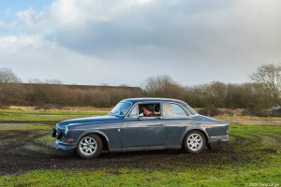
Paul Dyas and Michael Gilbey in the Volvo Amazon.Photo by Tony Large
At the rest halt Warren/Tullie led Crosby/Procter by 21 seconds with Turner/Heriot and Mayne/Robinson leading the Classes.
As darkness fell the crews went back for 3 more tests, on the first Dyas/Gilbey took 26 seconds out of the field to take the lead in the rally, Turner/Heriot and Hodge/Raine continued to maintain class advantage. The next test the longest of the rally at 5.3 miles saw Ian Crammond/Matt Vokes (Merc 280SL) take fastest, Hugh Garnish/David Bell (205GTi) put in a great run as only 3 Experts beat bogey and all the Novices took bogeys.
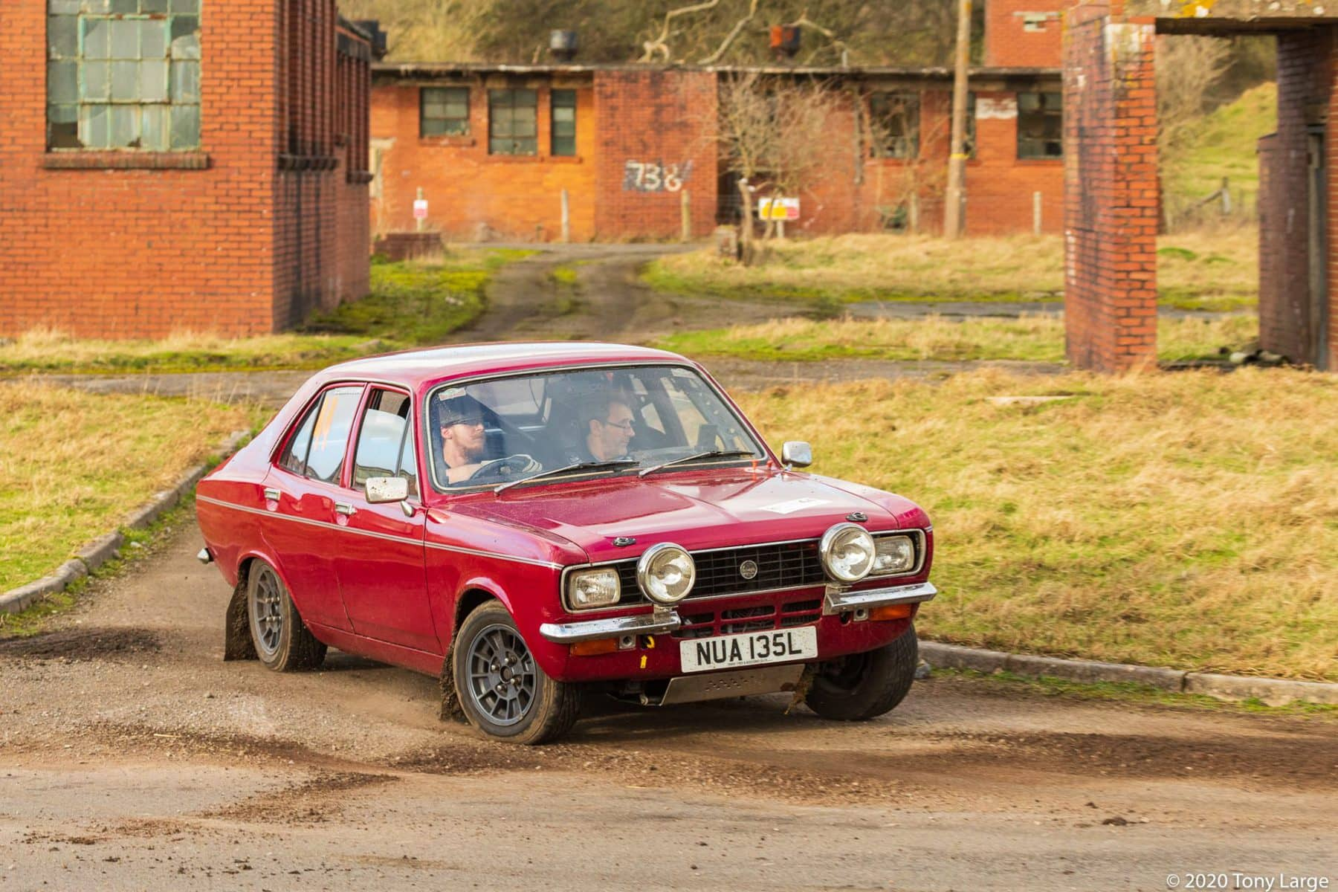

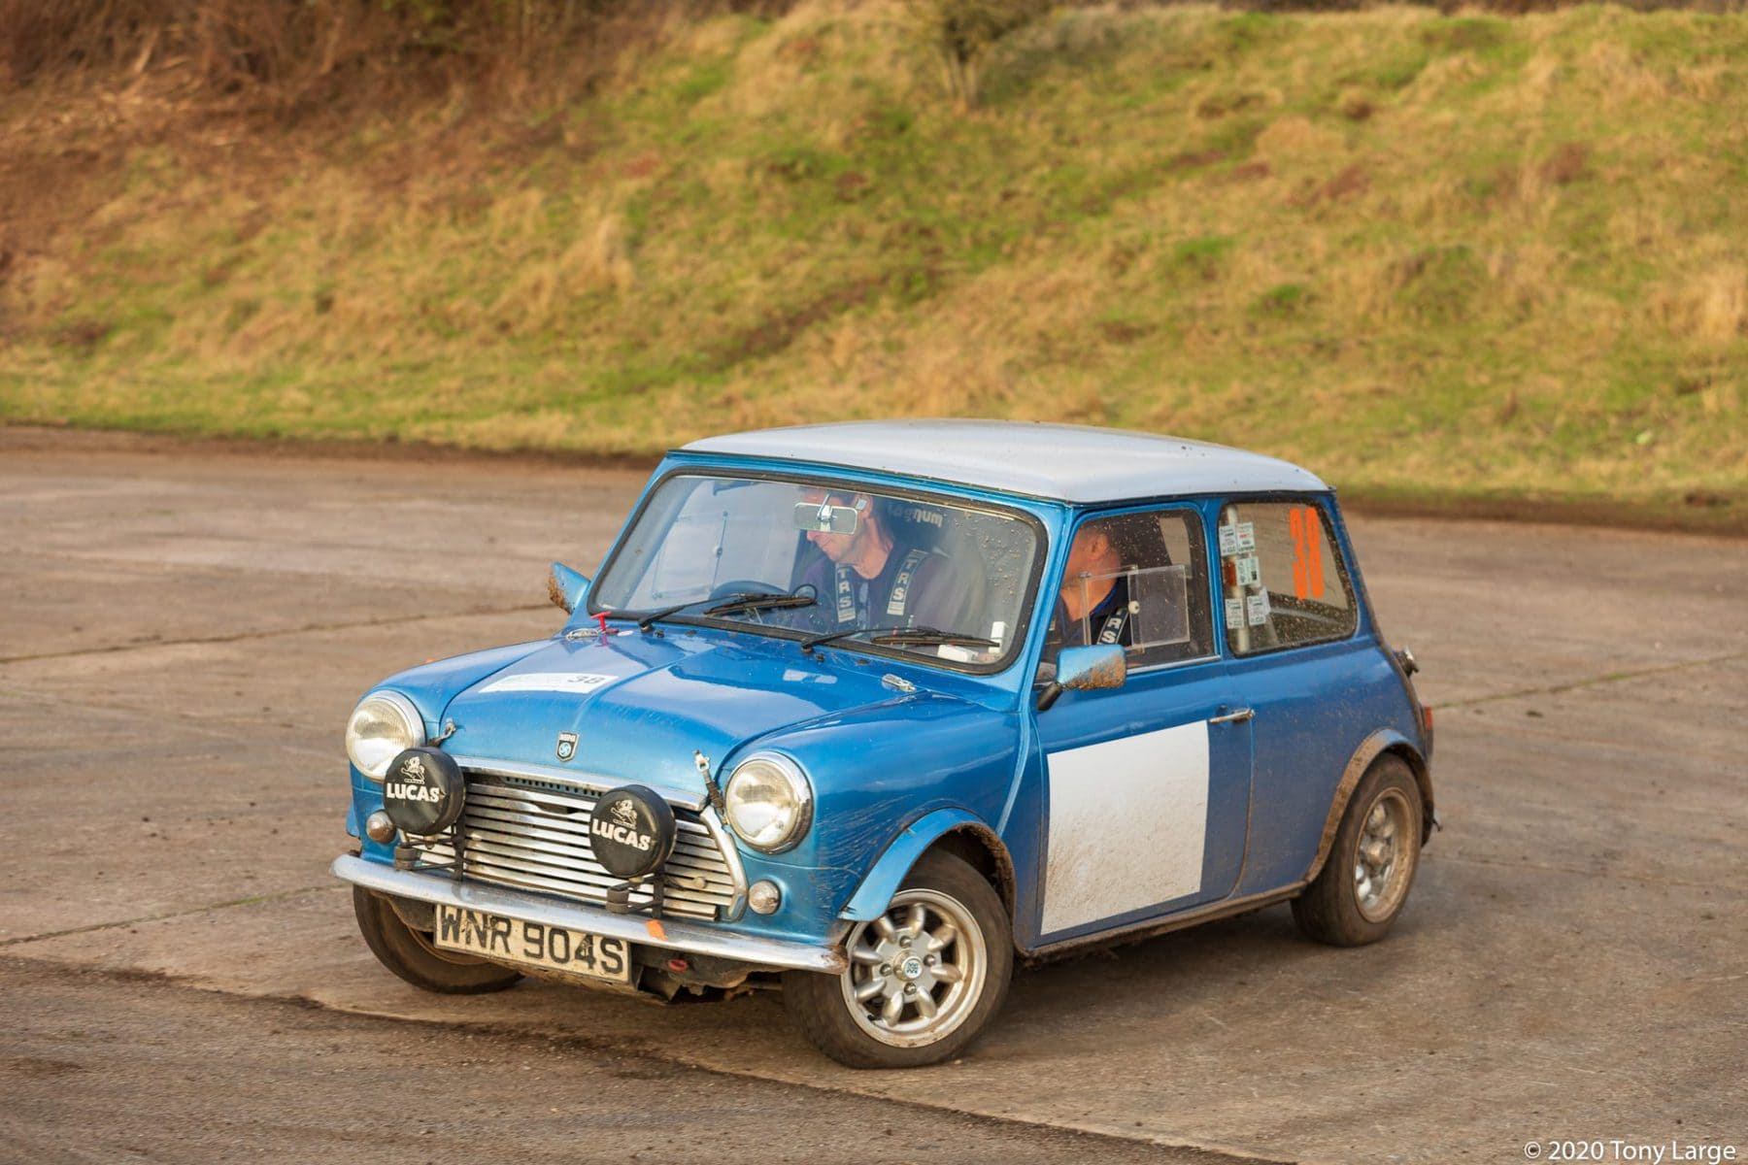
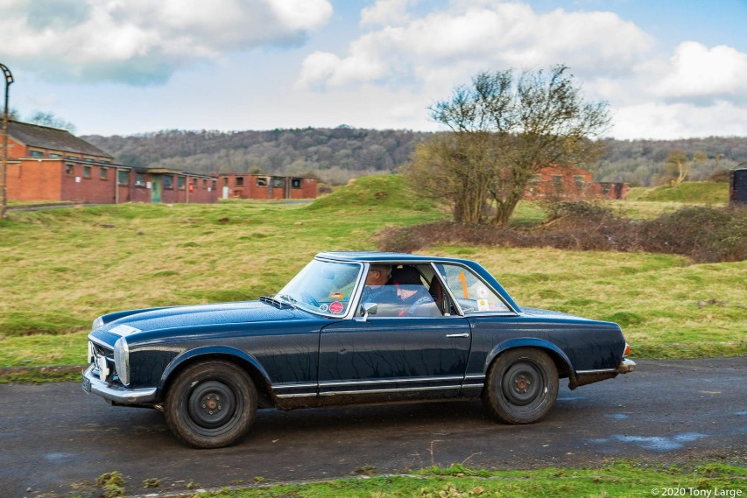

All photos by Tony Large
The last test saw the good run of Goodwin/Davies come to an end with electrical failure, Crosby/Procter won and guest driver Matt Nichol-Jones getting to grips with the car and rallying, it was his first ever rally, put in a great time to be 4th quickest. Garnish/Bell took another chunk out of the Expert class moving them into the top 10 and Hodge/Raine took the Novices
All that remained was 3 regularities, the first and third were handouts at the start Controls so navigators were under pressure. The first of these was made more difficult as it was a printed map with the instruction on the reverse, Dyas/Gilbey triumphed. Reg 4 already plotted saw Dyas/Gilbey’s hopes of win dashed as they missed a code board Crammond/Vokes and Andre Scruten/John Youd (Porsche 911) shared honours on 12, Experts Roger Powley/Brian Goff got through on 30 seconds whilst all the Novices missed at least one control.
The final reg again a hand out at the start Control caught out most using the A40 dual carriageway both ways only 9 cars found all the controls and only 2 of those managed without incurring a minutes penalty somewhere, take a bow Jenkins/Brooks winners from Garnish/Bell.
At the finish there was universal praise for Paul Morris and his Team at Ross and District their event offered new ideas and although it was really tough it was really rewarding.
Results:- Warren/Tullie (911) 83.56; Crosby/Procter (911) 88.30; Dyas/Gilbey (Amazon) 90.37; Crammond/Vokes (280SL) 91.56; Garnish/Bell (205 GTi) 99.06; Rogers/Rogers (Scimitar) 99.38; Turner/Heriot (Talbot) 100.33; Hughes/Hughes (B GT) 103.07; Jenkins/Brooks (SAAB) 103.47; Nichol-Jones/Phaff (Fulvia) 107.37
experts:- Garnish/Bell; novices:- Smith/Hawken (Mini)
Martin Phaff

